***ZABBIX AGENT ADD IN LOG SERVER***

* **LOG SERVER KE ANDAR EK PATH HONA CHAHIYE OR AGR PATH NHI H TO BANNA HAI**

**PATH MOST IMP == { Root/H8LogMonitor/ }**

* **EK FILE HAI VO FILE JAHA PE INSTALL KARNA HAI VAHA PE LEKE JANA HAI**

**FILE NAME == [ Moniterscriptv6.sh ]**

* **ISH FILE KO EXCUTEBLE BANNANA HAI**

**COMMAD == [ #chmod 775 monitringscriptv6.sh ]**

* **SERVICE CHECK KARNI HAI CALU HAI YA NHI ZABBIX VALI**

**SERVICE NAME== [ #systeamctl status zabbix-agent2 ]**

* **ISH FILE PATH OR KEY ENABLE KARNI H   
    
  [ #vi configuration.sh ]**
* **NOTE = AGR LOG IST TIME ME AARHE HAI TOH [SYSLOG ENABLE ] KARNA HAI [ ENABLE KEY= 1 ]**
* **NOTE = AGR LOGT UTC TIME ME AARHE HAI TO [ NETFLOW ENABLE ]**

**KARNA HAI [ ENABLE KEY 1 ]**

* **NOTE = AGR LOG IST TIME ME AARHE HAI TOH LOG PATH [ SYSLOG ] ME DALNA HAI // OR UTC ME AARHE HAI TO [ CFLOW ] ME DALNA HAI PATH**

* **NOTE = AGR LOG PATH MULTIPLE HAI TOH ISH TARAH PATH LIKHNA HAI   
    
  TAYPE = [ */ HOME/SYSLOG/IPFIX:/HOME/H8LOG/CFLOW/IPFIX ]***

***[* PATH = UTC/IST TIME KE ACCODING MANTION KARNA HAI ]**

* **EK FILE MOVE KARNI HAI   
    
  COMMAD = [ #mv *home*/dhruv/log/ipdr.log/ *home*dhruv/log/oldipdr.log ]**

* **CRONTAB OPEN KARNI HAI OR TIMEMING CHANGR KARNA HAI  
    
  #crontab -e [ */30 * * * * /*Root /H8LogMonitor/monitorscriptipv6,sh ]   
    
  pele crontab me 30 ki jagah 15 tha or apn ko 30 karna hai***

* **EK FILE CONFIGURE KARNA HAI   
    
  COMMAD = [ vi /etc /zabbix / *zabbix.conf/ ]*ISH FILE KE ANDR [ SHIFT:/202/ ] PE JAKAR   
    
  BBIX SERVER IP CHNAGE KARNA HAI [ 217.15.160.200 ] ZABBIX SERVER IP**
* **NOTE = 2 JAGAH PE IP MANTION KARNA HAI SAME UPAR VALA PROCESS KARKE**
* **THAN SERVICE RESTART THIS COMMAD   
    
  { # SYSTEAMCTL RESTART ZABBIX-AGET2 }**

* **CHECK THE ZABBIX SERVICE RUNNIG OR NOT PLEASE RUN THIS COMMAD   
    
  { # SYSTEAMCTL STATUS ZABBIX-AGET2 }**
* **New script accoding jishpe syslogt service hai toh ushki conf. File me jake**

**N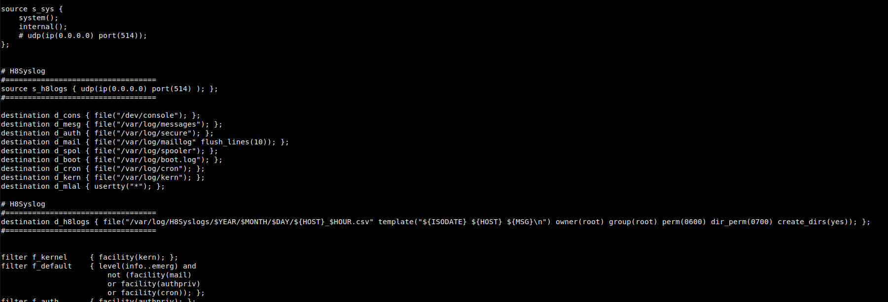OTE = ushme path pe [ .log ki jagah / .csv ] karna hai   
  
  
  
jishme zabbix add karte hai ushke log server me joh service chal rahi hai ushki config file me**

**log agr === . log extesion hai toh ushko . csv karna hai**